CS 2265 – Advanced Programming I (Using Java)
Program #1 – Garrett Jones

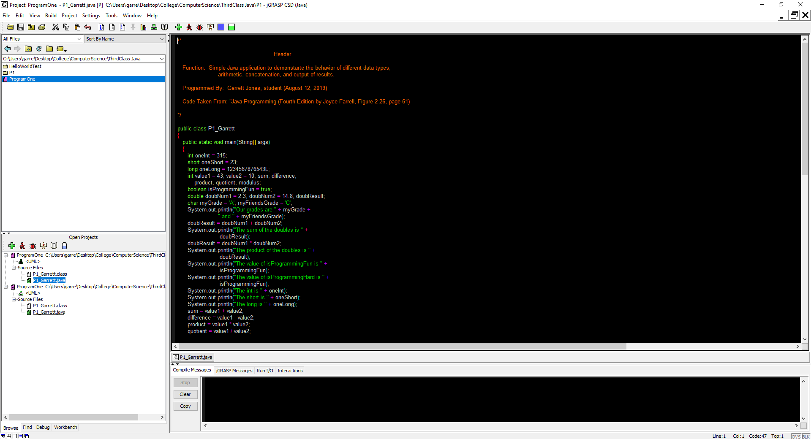

Source code:

/*
Header
Function: Simple Java application to demonstrate the behavior of different data types,
arithmetic, concatenation, and output of results.
Programmed By: Garrett Jones, student (August 12, 2019)
Code Taken From: "Java Programming (Fourth Edition by Joyce Farrell, Figure 2-26, page 61)
*/
public class P1_Garrett
{
public static void main(String[] args)
{
int oneInt = 315;
short oneShort = 23;
long oneLong = 1234567876543L;
int value1 = 43, value2 = 10, sum, difference,
product, quotient, modulus;
boolean isProgrammingFun = true;
double doubNum1 = 2.3, doubNum2 = 14.8, doubResult;
char myGrade = 'A', myFriendsGrade = 'C';
System.out.println("Our grades are " + myGrade +
" and " + myFriendsGrade);
doubResult = doubNum1 + doubNum2;
System.out.println("The sum of the doubles is " +
doubResult);
doubResult = doubNum1 * doubNum2;
System.out.println("The product of the doubles is " +
doubResult);
System.out.println("The value of isProgrammingFun is " +
isProgrammingFun);
System.out.println("The value of isProgrammingHard is " +
isProgrammingFun);
System.out.println("The int is " + oneInt);
System.out.println("The short is " + oneShort);
System.out.println("The long is " + oneLong);
sum = value1 + value2;
difference = value1 - value2;
product = value1 * value2;
quotient = value1 / value2;
modulus = value1 % value2;
System.out.println("Sum is " + sum);
System.out.println("Difference is " + difference);
System.out.println("Product is " + product);
System.out.println("Quotient is " + quotient);
System.out.println("Modulus is " + modulus);
System.out.println("\nThis is on one line\nThis on another");
System.out.println("This shows\thow\ttabs\twork");
} // end method main
} // end class P1_Garrett

Output:

